**CNS Lab**

**Assignment 3**

**Title: Study of Railfence Cipher**

**Information:**

The Rail Fence Cipher, also known as the Zigzag Cipher, is a simple transposition cipher that rearranges the letters of a message to encrypt it. It gets its name because the letters are arranged in a zigzag pattern that resembles a fence made of rails. Here's how the Rail Fence Cipher works:

1. Encryption:

- Write the message in a "rail fence" pattern, which means that the letters are arranged in a zigzag pattern, like the rails of a fence. The number of "rails" or rows is the key to the cipher. For example, if you're using three rails, you would arrange the message like this:

```

R . . . I . . . L . . . F . . . E . . . N . . . C . .

. A . I . R . C . E . P . H . O . N . . . . . . . . . . . .

. . L . . . E . . . I . . . S . . . . . . . . . . . . . . .

```

- Read the message from left to right along each rail, combining the letters to create the ciphertext. In this example, the ciphertext would be "RILFCENAIREPHO."

2. Decryption:

- To decrypt a message encrypted with the Rail Fence Cipher, you need to know the number of rails used for encryption. If you don't know the number of rails, you may need to try different possibilities.

- Write out the rails in the same pattern as used for encryption, with empty slots for the letters of the message.

- Fill in the ciphertext along the rails in the zigzag pattern.

- Read the message from the rails to reveal the original plaintext.

Here's an example of decryption for the ciphertext "RILFCENAIREPHO" using three rails:

```

R . . . I . . . L . . . F . . . E . . . N . . . C . .

. A . I . R . C . E . P . H . O . N . . . . . . . . . . . .

. . L . . . E . . . I . . . S . . . . . . . . . . . . . . .

Decrypted message: "RAILFENCECIPHER"

```

The Rail Fence Cipher is relatively easy to use, but it's not very secure. It's primarily used for educational purposes or as a fun way to encrypt messages rather than for serious encryption or security.

**Code:**

def encrypt_rail_fence(text, rails):

    rail_rows = ['' for _ in range(rails)]

    current_rail = 0

    direction = 1

    for char in text:

        rail_rows[current_rail] += char

        if current_rail == 0:

            direction = 1

        elif current_rail == rails - 1:

            direction = -1

        current_rail += direction

    encrypted_text = ''.join(rail_rows)

    return encrypted_text

def decrypt_rail_fence(ciphertext, rails):

    rail_rows = ['' for _ in range(rails)]

    # Calculate the number of characters in each rail

    rail_lengths = [0] * rails

    current_rail = 0

    direction = 1

    for char in ciphertext:

        rail_lengths[current_rail] += 1

        if current_rail == 0:

            direction = 1

        elif current_rail == rails - 1:

            direction = -1

        current_rail += direction

    # Fill the rail rows with characters from the ciphertext

    idx = 0

    for i in range(rails):

        rail_rows[i] = ciphertext[idx:idx + rail_lengths[i]]

        idx += rail_lengths[i]

    # Decrypt the ciphertext

    current_rail = 0

    direction = 1

    decrypted_text = ''

    for _ in range(len(ciphertext)):

        decrypted_text += rail_rows[current_rail][0]

        rail_rows[current_rail] = rail_rows[current_rail][1:]

        if current_rail == 0:

            direction = 1

        elif current_rail == rails - 1:

            direction = -1

        current_rail += direction

    return decrypted_text

plaintext = "Kill POTUS"

rails = 2

ciphertext = encrypt_rail_fence(plaintext, rails)

print("Encrypted text:", ciphertext)

decrypted_text = decrypt_rail_fence(ciphertext, rails)

print("Decrypted text:", decrypted_text)

**Output:**

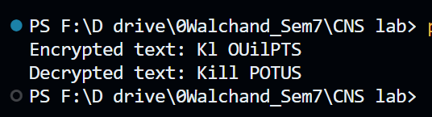

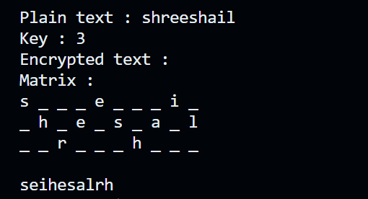

**Limitations:**

1. Lack of Security: The Rail Fence Cipher provides only basic security and is susceptible to various cryptographic attacks. It does not offer robust protection against determined attackers.

2. Weak Encryption: The cipher's encryption process involves rearranging characters in a predictable and systematic manner. This makes it vulnerable to frequency analysis and pattern recognition.

3. Small Key Space: The number of rails (rows) used as the key determines the security of the cipher. However, the key space is relatively small, making it susceptible to brute-force attacks, especially when the number of rails is low.

4. Known Structure: The structure of the Rail Fence Cipher is evident in the ciphertext. The number of rails used in encryption can often be determined by analyzing the length of the ciphertext. This can aid attackers in deciphering the message.

5. Key Management: Securely managing and distributing the key (i.e., the number of rails) can be challenging, especially in scenarios involving multiple users or communication channels.

6. Inefficient for Large Messages: For long messages, the Rail Fence Cipher can be inefficient and result in a long ciphertext, which may not be practical for transmission or storage.

7. No Authentication or Integrity Protection: The Rail Fence Cipher only provides confidentiality. It does not offer any form of authentication or data integrity protection. As a result, an attacker can tamper with the ciphertext without detection.

8. Limited Applicability: The Rail Fence Cipher is primarily designed for text-based data. It may not work well for encrypting other types of data or data with different character sets.

9. Not Suitable for Modern Cryptographic Needs: Given its limitations, the Rail Fence Cipher is not suitable for securing sensitive or valuable information in contemporary applications. More advanced encryption methods should be used for strong data protection.